int [**ip\_forward**](http://lxr.free-electrons.com/ident?i=ip_forward) (struct [sk\_buff](http://lxr.free-electrons.com/ident?i=sk_buff) \*[skb](http://lxr.free-electrons.com/ident?i=skb))

{

[**U32**](http://lxr.free-electrons.com/ident?i=u32)[**mtu**](http://lxr.free-electrons.com/ident?i=mtu)**;**  //**static int** [**mtu**](http://lxr.free-electrons.com/ident?i=mtu)**[**[**MAX\_UNITS**](http://lxr.free-electrons.com/ident?i=MAX_UNITS)**]; */\* Jumbo MTU for interfaces. \*/***

A **maximum transmission unit** (**MTU**) is the largest size packet or frame, specified in octets (eight-bit bytes), that can be sent in a packet- or frame-based **network** such as the Internet. The Internet's Transmission Control Protocol (TCP) uses the **MTU** to determine the maximum size of each packet in any transmission.

---------------------------------------------------------------------------------------------------------------------------------

**struct** [**iphdr**](http://lxr.free-electrons.com/ident?i=iphdr) **\*iph; */\* Our header \*/***

**struct** [**iphdr**](http://lxr.free-electrons.com/ident?i=iphdr) **{**

**#if defined([\_\_LITTLE\_ENDIAN\_BITFIELD](http://lxr.free-electrons.com/ident?i=__LITTLE_ENDIAN_BITFIELD))**

[**\_\_u8**](http://lxr.free-electrons.com/ident?i=__u8) **ihl:4,**

[**version**](http://lxr.free-electrons.com/ident?i=version)**:4;**

**#elif defined (**[**\_\_BIG\_ENDIAN\_BITFIELD**](http://lxr.free-electrons.com/ident?i=__BIG_ENDIAN_BITFIELD)**)**

[**\_\_u8**](http://lxr.free-electrons.com/ident?i=__u8)[**version**](http://lxr.free-electrons.com/ident?i=version)**:4,**

**ihl:4;**

**#else**

**#error *"Please fix <asm/byteorder.h>"***

**#endif**

[**\_\_u8**](http://lxr.free-electrons.com/ident?i=__u8) **tos;**

[**\_\_be16**](http://lxr.free-electrons.com/ident?i=__be16) **tot\_len;**

[**\_\_be16**](http://lxr.free-electrons.com/ident?i=__be16)[**id**](http://lxr.free-electrons.com/ident?i=id)**;**

[**\_\_be16**](http://lxr.free-electrons.com/ident?i=__be16) **frag\_off;**

[**\_\_u8**](http://lxr.free-electrons.com/ident?i=__u8)[**ttl**](http://lxr.free-electrons.com/ident?i=ttl)**;**

[**\_\_u8**](http://lxr.free-electrons.com/ident?i=__u8)[**protocol**](http://lxr.free-electrons.com/ident?i=protocol)**;**

[**\_\_sum16**](http://lxr.free-electrons.com/ident?i=__sum16)[**check**](http://lxr.free-electrons.com/ident?i=check)**;**

[**\_\_be32**](http://lxr.free-electrons.com/ident?i=__be32)[**saddr**](http://lxr.free-electrons.com/ident?i=saddr)**;**

[**\_\_be32**](http://lxr.free-electrons.com/ident?i=__be32)[**daddr**](http://lxr.free-electrons.com/ident?i=daddr)**;**

***/\*The options start here. \*/***

**};**

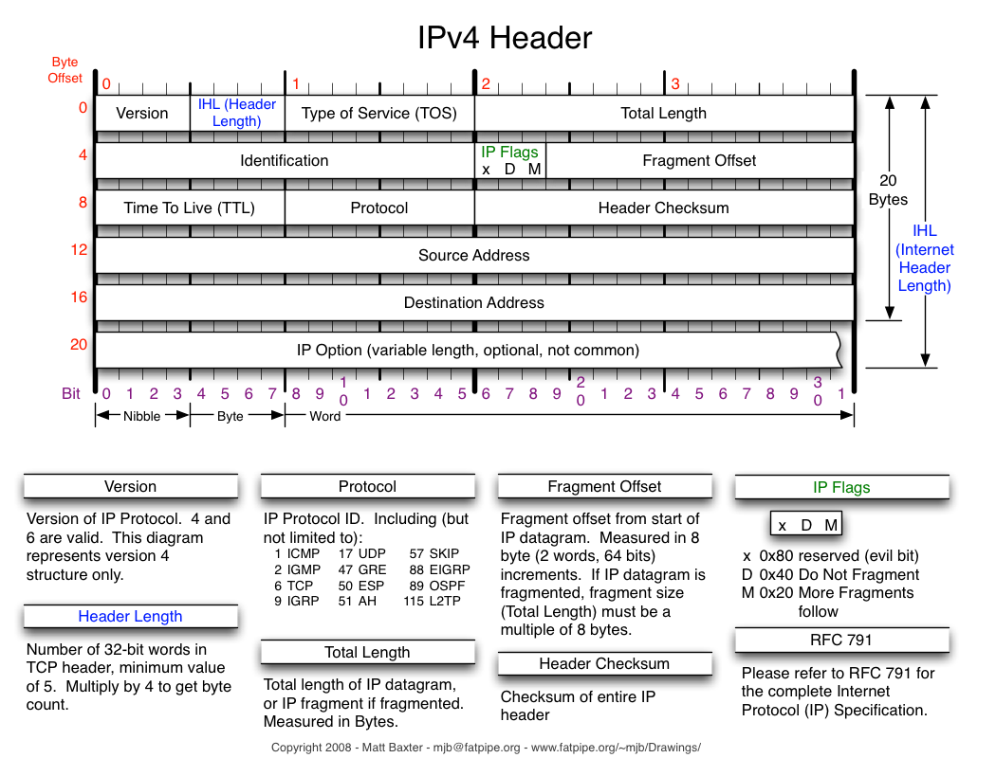

---------------------------------------------------------------------------------------------------------------------------------

**struct** [**rtable**](http://lxr.free-electrons.com/ident?i=rtable) **\***[**rt**](http://lxr.free-electrons.com/ident?i=rt)**; */\* Route we use \*/***

**struct** [**rtable**](http://lxr.free-electrons.com/ident?i=rtable) **{**

**struct** [**dst\_entry**](http://lxr.free-electrons.com/ident?i=dst_entry)[**dst**](http://lxr.free-electrons.com/ident?i=dst)**;**

**int rt\_genid;**

**unsigned int rt\_flags;**

[**\_\_u16**](http://lxr.free-electrons.com/ident?i=__u16) **rt\_type;**

[**\_\_u8**](http://lxr.free-electrons.com/ident?i=__u8) **rt\_is\_input;**

[**\_\_u8**](http://lxr.free-electrons.com/ident?i=__u8) **rt\_uses\_gateway;**

**int rt\_iif;**

***/\* Info on neighbour \*/***

[**\_\_be32**](http://lxr.free-electrons.com/ident?i=__be32) **rt\_gateway;**

***/\* Miscellaneous cached information \*/***

[**u32**](http://lxr.free-electrons.com/ident?i=u32) **rt\_pmtu;**

**struct** [**list\_head**](http://lxr.free-electrons.com/ident?i=list_head) **rt\_uncached;**

**#define** [**list\_head**](http://lxr.free-electrons.com/ident?i=list_head)**(**[**list**](http://lxr.free-electrons.com/ident?i=list)**,** [**type**](http://lxr.free-electrons.com/ident?i=type)**, member) \**

[**list\_entry**](http://lxr.free-electrons.com/ident?i=list_entry)**((**[**list**](http://lxr.free-electrons.com/ident?i=list)**)->**[**next**](http://lxr.free-electrons.com/ident?i=next)**,** [**type**](http://lxr.free-electrons.com/ident?i=type)**, member)**

**struct** [**uncached\_list**](http://lxr.free-electrons.com/ident?i=uncached_list) **\*rt\_uncached\_list;**

**struct** [**uncached\_list**](http://lxr.free-electrons.com/ident?i=uncached_list) **{**

[**spinlock\_t**](http://lxr.free-electrons.com/ident?i=spinlock_t)[**lock**](http://lxr.free-electrons.com/ident?i=lock)**;**

**struct** [**list\_head**](http://lxr.free-electrons.com/ident?i=list_head)[**head**](http://lxr.free-electrons.com/ident?i=head)**;**

**};**

**};**

**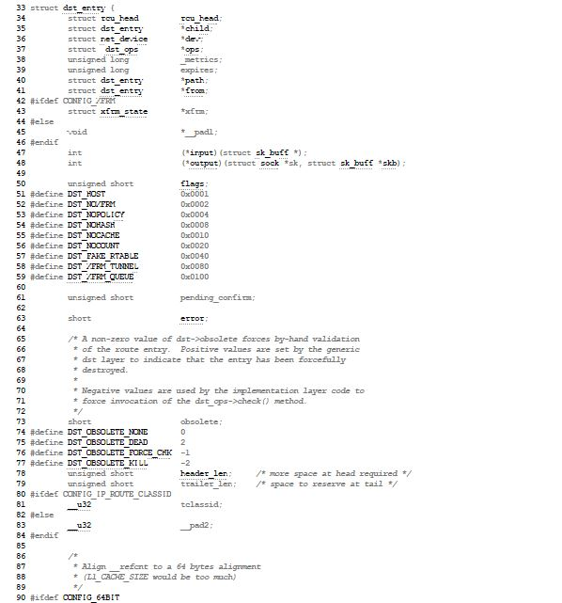**

**------------------------------------------------------------------------------------------------------------------------------- -**

struct [ip\_options](http://lxr.free-electrons.com/ident?i=ip_options) \*opt = &([IPCB](http://lxr.free-electrons.com/ident?i=IPCB)([skb](http://lxr.free-electrons.com/ident?i=skb))->opt);

***/\* that should never happen \*/***

[86](http://lxr.free-electrons.com/source/net/ipv4/ip_forward.c" \l "L86" \t "_blank) if ([skb](http://lxr.free-electrons.com/ident?i=skb)->pkt\_type != [PACKET\_HOST](http://lxr.free-electrons.com/ident?i=PACKET_HOST))

[87](http://lxr.free-electrons.com/source/net/ipv4/ip_forward.c" \l "L87" \t "_blank) goto [drop](http://lxr.free-electrons.com/ident?i=drop);

[88](http://lxr.free-electrons.com/source/net/ipv4/ip_forward.c" \l "L88" \t "_blank)

[89](http://lxr.free-electrons.com/source/net/ipv4/ip_forward.c" \l "L89" \t "_blank) if ([unlikely](http://lxr.free-electrons.com/ident?i=unlikely)([skb](http://lxr.free-electrons.com/ident?i=skb)->sk))

[90](http://lxr.free-electrons.com/source/net/ipv4/ip_forward.c" \l "L90" \t "_blank) goto [drop](http://lxr.free-electrons.com/ident?i=drop);

[91](http://lxr.free-electrons.com/source/net/ipv4/ip_forward.c" \l "L91" \t "_blank)

[92](http://lxr.free-electrons.com/source/net/ipv4/ip_forward.c" \l "L92" \t "_blank) if ([skb\_warn\_if\_lro](http://lxr.free-electrons.com/ident?i=skb_warn_if_lro)([skb](http://lxr.free-electrons.com/ident?i=skb)))

[93](http://lxr.free-electrons.com/source/net/ipv4/ip_forward.c" \l "L93" \t "_blank) goto [drop](http://lxr.free-electrons.com/ident?i=drop);

[94](http://lxr.free-electrons.com/source/net/ipv4/ip_forward.c" \l "L94" \t "_blank)

[95](http://lxr.free-electrons.com/source/net/ipv4/ip_forward.c" \l "L95" \t "_blank) if (![xfrm4\_policy\_check](http://lxr.free-electrons.com/ident?i=xfrm4_policy_check)([NULL](http://lxr.free-electrons.com/ident?i=NULL), XFRM\_POLICY\_FWD, [skb](http://lxr.free-electrons.com/ident?i=skb)))

[96](http://lxr.free-electrons.com/source/net/ipv4/ip_forward.c" \l "L96" \t "_blank) goto [drop](http://lxr.free-electrons.com/ident?i=drop);

[97](http://lxr.free-electrons.com/source/net/ipv4/ip_forward.c" \l "L97" \t "_blank)

[98](http://lxr.free-electrons.com/source/net/ipv4/ip_forward.c" \l "L98" \t "_blank) if ([IPCB](http://lxr.free-electrons.com/ident?i=IPCB)([skb](http://lxr.free-electrons.com/ident?i=skb))->opt.router\_alert && [ip\_call\_ra\_chain](http://lxr.free-electrons.com/ident?i=ip_call_ra_chain)([skb](http://lxr.free-electrons.com/ident?i=skb)))

[99](http://lxr.free-electrons.com/source/net/ipv4/ip_forward.c" \l "L99" \t "_blank) return [NET\_RX\_SUCCESS](http://lxr.free-electrons.com/ident?i=NET_RX_SUCCESS);

[100](http://lxr.free-electrons.com/source/net/ipv4/ip_forward.c" \l "L100" \t "_blank)

[101](http://lxr.free-electrons.com/source/net/ipv4/ip_forward.c" \l "L101" \t "_blank) [skb\_forward\_csum](http://lxr.free-electrons.com/ident?i=skb_forward_csum)([skb](http://lxr.free-electrons.com/ident?i=skb));

[102](http://lxr.free-electrons.com/source/net/ipv4/ip_forward.c" \l "L102" \t "_blank)

[103](http://lxr.free-electrons.com/source/net/ipv4/ip_forward.c" \l "L103" \t "_blank) ***/\****

[104](http://lxr.free-electrons.com/source/net/ipv4/ip_forward.c" \l "L104" \t "_blank)  ***\* According to the RFC, we must first decrease the TTL field. If***

[105](http://lxr.free-electrons.com/source/net/ipv4/ip_forward.c" \l "L105" \t "_blank)  ***\* that reaches zero, we must reply an ICMP control message telling***

[106](http://lxr.free-electrons.com/source/net/ipv4/ip_forward.c" \l "L106" \t "_blank)  ***\* that the packet's lifetime expired.***

[107](http://lxr.free-electrons.com/source/net/ipv4/ip_forward.c" \l "L107" \t "_blank)  ***\*/***

[108](http://lxr.free-electrons.com/source/net/ipv4/ip_forward.c" \l "L108" \t "_blank) if ([ip\_hdr](http://lxr.free-electrons.com/ident?i=ip_hdr)([skb](http://lxr.free-electrons.com/ident?i=skb))->[ttl](http://lxr.free-electrons.com/ident?i=ttl) <= 1)

[109](http://lxr.free-electrons.com/source/net/ipv4/ip_forward.c" \l "L109" \t "_blank) goto too\_many\_hops;

[110](http://lxr.free-electrons.com/source/net/ipv4/ip_forward.c" \l "L110" \t "_blank)

[111](http://lxr.free-electrons.com/source/net/ipv4/ip_forward.c" \l "L111" \t "_blank) if (![xfrm4\_route\_forward](http://lxr.free-electrons.com/ident?i=xfrm4_route_forward)([skb](http://lxr.free-electrons.com/ident?i=skb)))

[112](http://lxr.free-electrons.com/source/net/ipv4/ip_forward.c" \l "L112" \t "_blank) goto [drop](http://lxr.free-electrons.com/ident?i=drop);

[113](http://lxr.free-electrons.com/source/net/ipv4/ip_forward.c" \l "L113" \t "_blank)

[114](http://lxr.free-electrons.com/source/net/ipv4/ip_forward.c" \l "L114" \t "_blank) [rt](http://lxr.free-electrons.com/ident?i=rt) = [skb\_rtable](http://lxr.free-electrons.com/ident?i=skb_rtable)([skb](http://lxr.free-electrons.com/ident?i=skb));

[115](http://lxr.free-electrons.com/source/net/ipv4/ip_forward.c" \l "L115" \t "_blank)

[116](http://lxr.free-electrons.com/source/net/ipv4/ip_forward.c" \l "L116" \t "_blank) if (opt->is\_strictroute && [rt](http://lxr.free-electrons.com/ident?i=rt)->rt\_uses\_gateway)

[117](http://lxr.free-electrons.com/source/net/ipv4/ip_forward.c" \l "L117" \t "_blank) goto sr\_failed;

[118](http://lxr.free-electrons.com/source/net/ipv4/ip_forward.c" \l "L118" \t "_blank)

[119](http://lxr.free-electrons.com/source/net/ipv4/ip_forward.c" \l "L119" \t "_blank) [IPCB](http://lxr.free-electrons.com/ident?i=IPCB)([skb](http://lxr.free-electrons.com/ident?i=skb))->[flags](http://lxr.free-electrons.com/ident?i=flags) |= [IPSKB\_FORWARDED](http://lxr.free-electrons.com/ident?i=IPSKB_FORWARDED);

[120](http://lxr.free-electrons.com/source/net/ipv4/ip_forward.c" \l "L120" \t "_blank) [mtu](http://lxr.free-electrons.com/ident?i=mtu) = [ip\_dst\_mtu\_maybe\_forward](http://lxr.free-electrons.com/ident?i=ip_dst_mtu_maybe_forward)(&[rt](http://lxr.free-electrons.com/ident?i=rt)->[dst](http://lxr.free-electrons.com/ident?i=dst), [true](http://lxr.free-electrons.com/ident?i=true));

[121](http://lxr.free-electrons.com/source/net/ipv4/ip_forward.c" \l "L121" \t "_blank) if ([ip\_exceeds\_mtu](http://lxr.free-electrons.com/ident?i=ip_exceeds_mtu)([skb](http://lxr.free-electrons.com/ident?i=skb), [mtu](http://lxr.free-electrons.com/ident?i=mtu))) {

[122](http://lxr.free-electrons.com/source/net/ipv4/ip_forward.c" \l "L122" \t "_blank) [IP\_INC\_STATS](http://lxr.free-electrons.com/ident?i=IP_INC_STATS)([dev\_net](http://lxr.free-electrons.com/ident?i=dev_net)([rt](http://lxr.free-electrons.com/ident?i=rt)->[dst](http://lxr.free-electrons.com/ident?i=dst).[dev](http://lxr.free-electrons.com/ident?i=dev)), IPSTATS\_MIB\_FRAGFAILS);

[123](http://lxr.free-electrons.com/source/net/ipv4/ip_forward.c" \l "L123" \t "_blank) [icmp\_send](http://lxr.free-electrons.com/ident?i=icmp_send)([skb](http://lxr.free-electrons.com/ident?i=skb), [ICMP\_DEST\_UNREACH](http://lxr.free-electrons.com/ident?i=ICMP_DEST_UNREACH), [ICMP\_FRAG\_NEEDED](http://lxr.free-electrons.com/ident?i=ICMP_FRAG_NEEDED),

[124](http://lxr.free-electrons.com/source/net/ipv4/ip_forward.c" \l "L124" \t "_blank) [htonl](http://lxr.free-electrons.com/ident?i=htonl)([mtu](http://lxr.free-electrons.com/ident?i=mtu)));

[125](http://lxr.free-electrons.com/source/net/ipv4/ip_forward.c" \l "L125" \t "_blank) goto [drop](http://lxr.free-electrons.com/ident?i=drop);

[126](http://lxr.free-electrons.com/source/net/ipv4/ip_forward.c" \l "L126" \t "_blank) }

[127](http://lxr.free-electrons.com/source/net/ipv4/ip_forward.c" \l "L127" \t "_blank)

[128](http://lxr.free-electrons.com/source/net/ipv4/ip_forward.c" \l "L128" \t "_blank) ***/\* We are about to mangle packet. Copy it! \*/***

[129](http://lxr.free-electrons.com/source/net/ipv4/ip_forward.c" \l "L129" \t "_blank) if ([skb\_cow](http://lxr.free-electrons.com/ident?i=skb_cow)([skb](http://lxr.free-electrons.com/ident?i=skb), [LL\_RESERVED\_SPACE](http://lxr.free-electrons.com/ident?i=LL_RESERVED_SPACE)([rt](http://lxr.free-electrons.com/ident?i=rt)->[dst](http://lxr.free-electrons.com/ident?i=dst).[dev](http://lxr.free-electrons.com/ident?i=dev))+[rt](http://lxr.free-electrons.com/ident?i=rt)->[dst](http://lxr.free-electrons.com/ident?i=dst).[header\_len](http://lxr.free-electrons.com/ident?i=header_len)))

[130](http://lxr.free-electrons.com/source/net/ipv4/ip_forward.c" \l "L130" \t "_blank) goto [drop](http://lxr.free-electrons.com/ident?i=drop);

[131](http://lxr.free-electrons.com/source/net/ipv4/ip_forward.c" \l "L131" \t "_blank) iph = [ip\_hdr](http://lxr.free-electrons.com/ident?i=ip_hdr)([skb](http://lxr.free-electrons.com/ident?i=skb));

[132](http://lxr.free-electrons.com/source/net/ipv4/ip_forward.c" \l "L132" \t "_blank)

[133](http://lxr.free-electrons.com/source/net/ipv4/ip_forward.c" \l "L133" \t "_blank) ***/\* Decrease ttl after skb cow done \*/***

[134](http://lxr.free-electrons.com/source/net/ipv4/ip_forward.c" \l "L134" \t "_blank) [ip\_decrease\_ttl](http://lxr.free-electrons.com/ident?i=ip_decrease_ttl)(iph);

[135](http://lxr.free-electrons.com/source/net/ipv4/ip_forward.c" \l "L135" \t "_blank)

[136](http://lxr.free-electrons.com/source/net/ipv4/ip_forward.c" \l "L136" \t "_blank) ***/\****

[137](http://lxr.free-electrons.com/source/net/ipv4/ip_forward.c" \l "L137" \t "_blank)  ***\* We now generate an ICMP HOST REDIRECT giving the route***

[138](http://lxr.free-electrons.com/source/net/ipv4/ip_forward.c" \l "L138" \t "_blank)  ***\* we calculated.***

[139](http://lxr.free-electrons.com/source/net/ipv4/ip_forward.c" \l "L139" \t "_blank)  ***\*/***

[140](http://lxr.free-electrons.com/source/net/ipv4/ip_forward.c" \l "L140" \t "_blank) if ([IPCB](http://lxr.free-electrons.com/ident?i=IPCB)([skb](http://lxr.free-electrons.com/ident?i=skb))->[flags](http://lxr.free-electrons.com/ident?i=flags) & [IPSKB\_DOREDIRECT](http://lxr.free-electrons.com/ident?i=IPSKB_DOREDIRECT) && !opt->[srr](http://lxr.free-electrons.com/ident?i=srr) &&

[141](http://lxr.free-electrons.com/source/net/ipv4/ip_forward.c" \l "L141" \t "_blank) ![skb\_sec\_path](http://lxr.free-electrons.com/ident?i=skb_sec_path)([skb](http://lxr.free-electrons.com/ident?i=skb)))

[142](http://lxr.free-electrons.com/source/net/ipv4/ip_forward.c" \l "L142" \t "_blank) [ip\_rt\_send\_redirect](http://lxr.free-electrons.com/ident?i=ip_rt_send_redirect)([skb](http://lxr.free-electrons.com/ident?i=skb));

[143](http://lxr.free-electrons.com/source/net/ipv4/ip_forward.c" \l "L143" \t "_blank)

[144](http://lxr.free-electrons.com/source/net/ipv4/ip_forward.c" \l "L144" \t "_blank) [skb](http://lxr.free-electrons.com/ident?i=skb)->[priority](http://lxr.free-electrons.com/ident?i=priority) = [rt\_tos2priority](http://lxr.free-electrons.com/ident?i=rt_tos2priority)(iph->tos);

[145](http://lxr.free-electrons.com/source/net/ipv4/ip_forward.c" \l "L145" \t "_blank)

[146](http://lxr.free-electrons.com/source/net/ipv4/ip_forward.c" \l "L146" \t "_blank) return [NF\_HOOK](http://lxr.free-electrons.com/ident?i=NF_HOOK)(NFPROTO\_IPV4, NF\_INET\_FORWARD, [NULL](http://lxr.free-electrons.com/ident?i=NULL), [skb](http://lxr.free-electrons.com/ident?i=skb),

[147](http://lxr.free-electrons.com/source/net/ipv4/ip_forward.c" \l "L147" \t "_blank) [skb](http://lxr.free-electrons.com/ident?i=skb)->[dev](http://lxr.free-electrons.com/ident?i=dev), [rt](http://lxr.free-electrons.com/ident?i=rt)->[dst](http://lxr.free-electrons.com/ident?i=dst).[dev](http://lxr.free-electrons.com/ident?i=dev), [ip\_forward\_finish](http://lxr.free-electrons.com/ident?i=ip_forward_finish));

[148](http://lxr.free-electrons.com/source/net/ipv4/ip_forward.c" \l "L148" \t "_blank)

[149](http://lxr.free-electrons.com/source/net/ipv4/ip_forward.c" \l "L149" \t "_blank) sr\_failed:

[150](http://lxr.free-electrons.com/source/net/ipv4/ip_forward.c" \l "L150" \t "_blank) ***/\****

[151](http://lxr.free-electrons.com/source/net/ipv4/ip_forward.c" \l "L151" \t "_blank)  ***\* Strict routing permits no gatewaying***

[152](http://lxr.free-electrons.com/source/net/ipv4/ip_forward.c" \l "L152" \t "_blank)  ***\*/***

[153](http://lxr.free-electrons.com/source/net/ipv4/ip_forward.c" \l "L153" \t "_blank) [icmp\_send](http://lxr.free-electrons.com/ident?i=icmp_send)([skb](http://lxr.free-electrons.com/ident?i=skb), [ICMP\_DEST\_UNREACH](http://lxr.free-electrons.com/ident?i=ICMP_DEST_UNREACH), [ICMP\_SR\_FAILED](http://lxr.free-electrons.com/ident?i=ICMP_SR_FAILED), 0);

[154](http://lxr.free-electrons.com/source/net/ipv4/ip_forward.c" \l "L154" \t "_blank) goto [drop](http://lxr.free-electrons.com/ident?i=drop);

[155](http://lxr.free-electrons.com/source/net/ipv4/ip_forward.c" \l "L155" \t "_blank)

[156](http://lxr.free-electrons.com/source/net/ipv4/ip_forward.c" \l "L156" \t "_blank) too\_many\_hops:

[157](http://lxr.free-electrons.com/source/net/ipv4/ip_forward.c" \l "L157" \t "_blank) ***/\* Tell the sender its packet died... \*/***

[158](http://lxr.free-electrons.com/source/net/ipv4/ip_forward.c" \l "L158" \t "_blank) [IP\_INC\_STATS\_BH](http://lxr.free-electrons.com/ident?i=IP_INC_STATS_BH)([dev\_net](http://lxr.free-electrons.com/ident?i=dev_net)([skb\_dst](http://lxr.free-electrons.com/ident?i=skb_dst)([skb](http://lxr.free-electrons.com/ident?i=skb))->[dev](http://lxr.free-electrons.com/ident?i=dev)), IPSTATS\_MIB\_INHDRERRORS);

[159](http://lxr.free-electrons.com/source/net/ipv4/ip_forward.c" \l "L159" \t "_blank) [icmp\_send](http://lxr.free-electrons.com/ident?i=icmp_send)([skb](http://lxr.free-electrons.com/ident?i=skb), [ICMP\_TIME\_EXCEEDED](http://lxr.free-electrons.com/ident?i=ICMP_TIME_EXCEEDED), [ICMP\_EXC\_TTL](http://lxr.free-electrons.com/ident?i=ICMP_EXC_TTL), 0);

[160](http://lxr.free-electrons.com/source/net/ipv4/ip_forward.c" \l "L160" \t "_blank) [drop](http://lxr.free-electrons.com/ident?i=drop):

[161](http://lxr.free-electrons.com/source/net/ipv4/ip_forward.c" \l "L161" \t "_blank) [kfree\_skb](http://lxr.free-electrons.com/ident?i=kfree_skb)([skb](http://lxr.free-electrons.com/ident?i=skb));

[162](http://lxr.free-electrons.com/source/net/ipv4/ip_forward.c" \l "L162" \t "_blank) return [NET\_RX\_DROP](http://lxr.free-electrons.com/ident?i=NET_RX_DROP);

[163](http://lxr.free-electrons.com/source/net/ipv4/ip_forward.c" \l "L163" \t "_blank) }

[164](http://lxr.free-electrons.com/source/net/ipv4/ip_forward.c" \l "L164" \t "_blank)